Achieving Accessibility in SharePoint 2010

Introduction
This document sets out the learning from Vision Australia’s experiences to date delivering an accessible implementation of SharePoint 2010, including our assessment of SharePoint 2010 conformance with the Web Content Accessibility Guidelines (WCAG 2.0).
Accessibility is becoming increasingly important for organisations in Australia. There are over 4 million people with a disability, expected to increase with our aging population. With the shift to increased use of the web for a range of services and information, organisations have a legal obligation under the Australian Disability Discrimination Act 1992 to ensure web content is fully accessible. There are also commercial advantages to ensuring web content meets the defined accessibility standards and best practices.
Most recently the Australian Government’s Web Accessibility National Transition Strategy requires government agencies to achieve WCAG 2.0 base level of conformance (Single A) by December 2012, and medium level (Double A) by the end of 2014.
Organisations are now taking a more proactive approach to accessibility. Rather than dealing with accessibility as an add-on prior to launching a website, organisations are addressing accessibility upfront as part of their normal IT governance and planning. As a result they are increasingly looking for platforms and tools that include accessibility out of the box and can more easily meet accessibility requirements.
Microsoft’s SharePoint platform is popular in business for functions such as collaboration, intranets and document management, often integrated with Office. The Microsoft Office SharePoint Server (MOSS) 2007 version presented a number of challenges to meeting accessibility needs. This paper reviews the significant improvements that have been made in SharePoint 2010, assesses conformance with WCAG 2.0 Double A standards, and provides guidance on how an accessible solution can be achieved using this platform.

Why is accessibility important?
The use of the Internet is changing the world we live in. For people with a disability, the Internet has the potential to provide equal access and independence. The ability online to pay bills, buy groceries, fill in your tax return, read government information and participate in communities are all examples of where online services have the potential to enrich the lives of people with a disability by providing a level of access that has not been available in the past.
The main disabilities that affect how people use the web include:
- Visual: blindness, low vision, colour blindness
- Cognitive: learning disabilities, problems with perception, poor memory, dyslexia
- Mobility: restricted upper body movement, inability to use a mouse, limited motor control
- Hearing: deafness or partial hearing
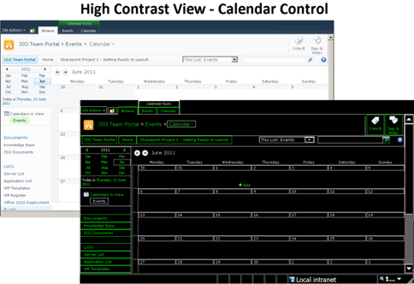
Each of these groups views and interacts with web content in different ways and requires different methods for accessibility. Methods include:
- providing keyboard access for people with mobility impairments
- captioning audio content for those with hearing impairment
- high contrast colours and text size adjustments for some visual disabilities
Others use specialised software or tools (also known as assistive technology). A common example is a screen reader used to speak out the information contained on the web page.
Web accessibility is about designing websites so they are available and usable by all these different users, regardless of how they view or interact with web content.
The World Wide Web Consortium’s (W3C) Web Content Accessibility Guidelines version 2 (WCAG 2.0) are widely recognised as a framework for designing an accessible website. Conformance with WCAG 2.0 is described using a three level rating system to identify the level of accessibility. Level Single A (A) is the basic level of conformance, followed by Double A (AA) and Triple A (AAA) – the highest. The Australian Government Web Accessibility National Transition Strategy (NTS) mandates that agencies must achieve WCAG 2.0 Single A conformance by the end of 2012 and Double A conformance by the end of 2014.
In addressing accessibility as part of an organisation’s web presence (including internets, intranets and extranets), trying to add-on or address accessibility after a website is built is costly and time-consuming. Sites will often fail to meet even the most basic level of conformance without significant effort.
Vision Australia’s experience shows the benefit of addressing accessibility upfront. Rigorous governance is required to ensure these requirements, and also overall usability, are met through design, testing and ongoing publication of content. Having tools and platforms that support accessibility is a key first step in making achievement of accessibility standards easier and part of normal business.

SharePoint 2010 as an Accessible Platform
SharePoint 2010 offers organisations a single platform that provides collaboration tools, document management and publishes intranet and internet sites. Importantly SharePoint 2010 also provides the building blocks that can be used to achieve accessibility conformance.
Microsoft Office SharePoint Server (MOSS) 2007 had a number of key failings from an accessibility perspective. Microsoft has worked to address many of these in the development of SharePoint 2010, with the target of achieving WCAG 2.0 Double A conformance out of the box.
Some of the accessibility improvements from MOSS 2007 include:
- enhanced keyboard access to all functionality including the new ribbon interface;
- changes to overcome technical conformance issues that occurred with master pages and controls in MOSS 2007;
- improved page reading sequences and representation of tabular data; and
- new accessibility features such as WAI-ARIA roles and attributes to enhance the experience of assistive technology users.
Out of the box SharePoint 2010 is much more accessible through the inclusion of WAI-ARIA. When used with the latest versions of browsers and assistive technologies the standard SharePoint interface is in many cases fully accessible.
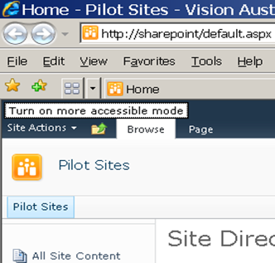
Where a suitable assistive technology is not available, Microsoft continues to provide the “More Accessible Mode”. This mode renders dynamic controls such as menus as standard HTML controls so they will work with a wider range of assistive technologies and provide a simpler interface for some users. This mode can however limit the actions available. More Accessible Mode can be accessed by pressing the TAB key immediately after placing focus on the page in a browser until the “Turn on more accessible mode” link is displayed.
SharePoint 2010 also includes major improvements in the use of metadata and search. As an interface, search is a familiar and efficient way for people who are blind or have a mobility impairment to manage and quickly navigate large volumes of information. Being able to configure and deploy search web parts more generally through the application supports easier access to large volumes of information.
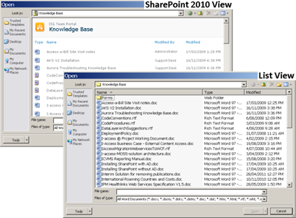
Used as an enterprise solution, SharePoint 2010 can provide the interface to multiple business systems. Properly configured and governed SharePoint 2010’s accessibility can then be delivered across multiple systems rather than having to address accessibility considerations for each system individually.
This overall platform approach means that users will see a common interface across multiple systems. This results in a simpler learning curve and reduces training and support requirements – which can be significant for users with a disability.
The close integration between SharePoint 2010 and Office 2010 also supports a “single accessible” platform approach. Office 2010 can be used to provide an alternative and familiar interface to SharePoint 2010 that for some functions is more accessible and easier to use. For example, using the traditional list view in the Open dialog of Word for document libraries is quicker for screen reader users to navigate.

Analysis of SharePoint WCAG 2.0 Conformance
As an organisation, accessibility is a core requirement for Vision Australia. Our stakeholders are people who are blind or have low vision and nearly 20% of our workforce (approximately 150 people) has a disability. To enable us to benefit from the value these individuals bring to our organisation, and support them to participate fully, accessibility conformance of our IT systems is an essential part of our day to day operation.
Vision Australia is implementing SharePoint 2010 to provide an enterprise solution addressing our document management and collaboration requirements, intranet and internet sites, and corporate approval processes. The first step of this implementation is focused on document management and collaboration.
To plan how we would address accessibility in SharePoint 2010 we completed an initial assessment of the document management and team site functions (excluding the administrative interfaces) against WCAG 2.0 Double A.
We assessed against each success criteria as either complying out of the box; requiring customisation to meet the criteria; or requiring a governance decision about how a function is implemented or not including a specific function to achieve conformance.
NOTE: Success criteria that relate specifically to content were assumed to comply out of the box (examples of these include providing alternatives for images and media and the use of colour).
The overall result of this analysis is shown below:
Approach to meet accessibility | LEVEL A  Success Criteria | LEVEL AA  Success Criteria
Out of the Box | 18 | 12
Customisation | 5 | 1
Governance | 2 | 0
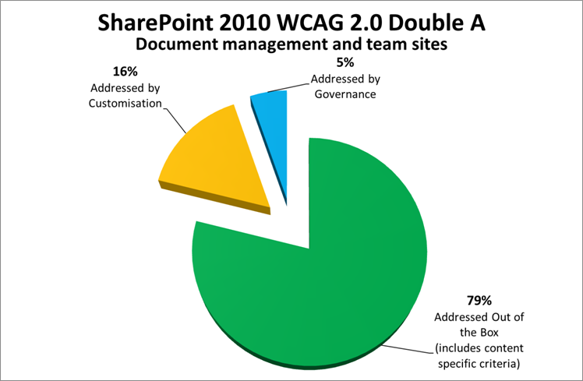
As this graph shows with a result of 79%, SharePoint 2010 can largely achieve accessibility conformance out of the box.
However, for any installation there remains a gap that needs to be filled through customisation and governance. The key gaps identified in the assessment were as follows:
- Page structure: the code generated by web components and master pages can introduce accessibility issues, particularly to do with structural elements such as heading, lists, tables, reading order and field labels. This can be addressed through re-rendering the HTML output of the non-conforming components.
- Rich text editor: the rich text editor provided with SharePoint 2010 does not meet accessibility requirements, particularly concerning the ability to operate the editor toolbar when using assistive technology. Using the enhanced rich text editor (where it is available in SharePoint 2010) or a third party add-on is recommended to address this.
- Complex interfaces: there are instances where functions with complex interfaces are not accessible - examples include the calendar control, people picker and the datasheet view control. Governance policies can support the use of alternative functionality or ensure these functions are avoided.
Overall our analysis concluded that SharePoint 2010 provides a solid foundation to achieve accessibility subject to suitable customisation and governance. Vision Australia has commenced our implementation on this basis.

Steps to Ensure Accessibility in SharePoint 2010
This section recommends specific customisation and governance policies to address the gaps identified above.

Customisation
Some level of customisation is required to achieve full conformance. The detail of this customisation will vary for each installation but typically needs to address:
- ensuring the code generated by web components and master pages contains correct page structure including heading levels, lists, tables and field labels;
- removing instances of unused or non-visible components so that pages are rendered with clean code and correct reading order;
- meeting specific accessibility requirements not met out of the box including providing unique page titles that describe the topic of the page and defining the correct language attribute on each page; and
- checking that any organisation specific changes, content, and branding also meet accessibility requirements.
By considering accessibility from the initial planning of a SharePoint implementation any customisation that is required can easily and effectively be incorporated into the general configuration that occurs as part of a SharePoint deployment. This minimises any additional development effort required to address accessibility.
When implementing these changes the aim is to use techniques that minimise the need to make direct changes to master pages or controls. There are several techniques available that suit different situations. Two common examples are using a control adapter to re-render the HTML provided by web components or using java script to add or remove elements from the HTML as the page loads. By adopting these techniques accessibility changes can be deployed across the site and packaged for re-use across multiple systems.

Governance
The analysis also highlighted that there are instances where governance is the preferred means to achieve accessibility. It may be more cost-effective to consider alternative options to implement a function or to exclude a specific function rather than undertake complex customisation.
Governance can also identify when to apply accessibility conformance and where it may be more appropriate to target the specific accessibility needs within your organisation. Vision Australia aims to achieve a combination of these approaches in our implementation of SharePoint 2010.
Effective governance decisions should consider:
- the purpose of the function, how often it is used, and what alternative options are available;
- an awareness of the user group requiring this function and how they view and interact with web content; and
- the severity of the accessibility problem considering both conformance and the real-world impact for people with a disability.
To demonstrate this we highlight several examples of how governance decisions have been used to achieve accessibility:

People Picker
The ‘people picker’ is provided as a quick way to assign permissions and tasks to other users for collaboration.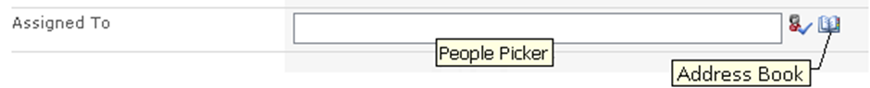
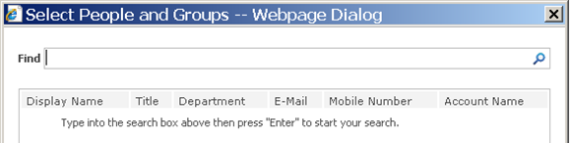
This function is accessible for some users but is not well supported by assistive technology. Rather than try and customise this functionality we decided to adopt the use of the alternative address book (select people and groups) function.

Document Approval
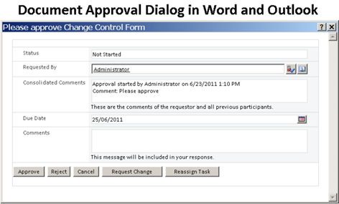
Task lists are used to notify users when they have documents requiring their approval. Our testing found accessibility problems with the views used for tasks in SharePoint 2010. When integrated with Office 2010, approval requests can be delivered via email and the approval can be performed in Office. In our case the option to use the Office 2010 interface addressed the accessibility problem with the benefit of provided a familiar interface and increased usability.

Rich Text Editor
There are accessibility problems with the rich text edit control provided out of the box with SharePoint 2010, particularly concerning the ability to operate the editor toolbar when using assistive technology. There are several third party options available that provide improved performance and accessibility conformance and adopting one of these is the recommended approach. Further, in some areas of SharePoint 2010 there is the option to use an enhanced rich text editor. This editor uses a ribbon UI that provides greater accessibility conformance than the standard editor.
As these examples show, the flexibility offered by SharePoint 2010 presents opportunities to use governance decisions to address accessibility problems in place of complex customisation. This approach is strengthened when using SharePoint 2010 with Office 2010 integration as Office provides a familiar and accessible environment for many users.

Maintaining an Accessible Website in SharePoint 2010
Some of the most common reasons why websites fail accessibility conformance is related to the content that is added to the site. Therefore in addition to ensuring that the base platform provided by SharePoint 2010 is accessible, it is equally important that web content meets accessibility requirements.
A strength of SharePoint 2010 is the ability for business areas within an organisation to manage their own web content. This presents a challenge to maintain accessibility conformance because while the core web team may be familiar with accessibility and WCAG 2.0, most content authors across an organisation are not.
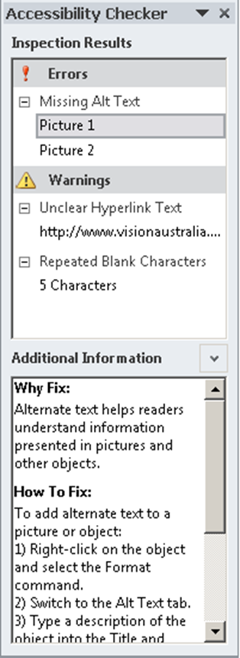
SharePoint 2010 offers several features, that coupled with appropriate training and strong governance practices, can support content authors throughout an organisation to create accessible web content and ensure that accessibility conformance is maintained:
- Use tools such as the Accessibility Checker built into Word 2010. This tool assists content authors to test new web content before they publish it. The accessibility checker detects common accessibility problems such as missing alternative text and the use of styles.
- Create workflows in SharePoint 2010 to define document approval paths including accessibility checks. For example, workflows can be used to request content authors complete an accessibility check or direct documents to qualified testers who check the document before it is published.
- Establish a set of templates, master pages, and web components that have been checked for accessibility and use these as the toolkit for content authors when building their own sites. Focusing on standard controls or ones that you built internally is one way to minimise accessibility customisation that might be required. This approach ensures that staff can take advantage of the flexibility of SharePoint while maintaining accessibility conformance.
There are also third party tools and add-ons available that can assist with testing and managing accessibility compliance.

Overall Conclusions and Recommendations
Our conclusions in this analysis are as follows:
- Significant progress has been made with out of the box accessibility in SharePoint 2010 and with appropriate customisation and governance decisions we believe SharePoint 2010 can achieve WCAG 2.0 Double A conformance.
- The main areas of non-conformance where customisation is required are fixing page structure, reading order problems and addressing specific accessibility requirements such as page titles and correct language attributes.
- For some functionality it may be more cost-effective to use alternative components or other functions to address accessibility problems rather than under take complex customisation. Governance policies are required to address this.
- A focus on accessibility from the initial stages of a SharePoint 2010 implementation is essential to successfully deliver the customisation and governance required to achieve conformance.
- In a distributed content environment, SharePoint 2010 offers features that assist with maintaining accessibility conformance including the ability to manage accessibility through deploying a specific set of conforming master pages and web components; the accessibility checker in Office 2010; and defining workflows to manage content approval processes.
- Used as an enterprise solution SharePoint 2010 can support organisation wide accessibility by providing a single platform that implements accessibility across multiple systems and offering a consistent and familiar user interface that leads to efficient training and support approaches for end users.
While SharePoint 2010 offers improved accessibility out of the box, a successful implementation is reliant on appropriate customisation and governance as part of a SharePoint deployment. Vision Australia has commenced our implementation of SharePoint 2010 on this basis.

Acknowledgement
Vision Australia acknowledges the support of Microsoft and the contribution to the development of this paper by John Wise of Wise Technology Management. John’s whitepapers on the implementation of SharePoint 2010 as a compliant information and records management solution can be found at www.wisetechnology.com.

Further Information
The following fact sheets may be obtained by emailing webaccess@visionaustralia.org:
- Ten Tips for a More Accessible Website, 2010
key accessibility considerations when designing and developing web content.
- Tips for Accessibility Testing Your Website, 2010
tools and techniques used for checking a web page for accessibility conformance.
- Tips for Assistive Technology Testing, 2010
simple steps for testing a website using assistive technology such as screen readers.
- Web Content Accessibility Guidelines, 2010
essential information you need to know about WCAG 2.0 conformance and how it relates to websites in Australia.
- Assistive Technology Guide, 2009
information about technology that assists people who are blind or have low vision.
- Computer Adjustments in Microsoft Windows for people with low vision, 2008
practical adjustments to support people who are blind or have low vision to use a computer.
Useful links about accessibility and SharePoint 2010:
- Web Content Accessibility Guidelines version 2.0
detailed reference to WCAG 2.0 including supporting materials – ‘how to meet WCAG 2.0’, ‘understanding WCAG 2.0’ and ‘techniques for WCAG 2.0’.
www.w3.org/WAI/intro/wcag
- Australian Government Web Accessibility National Transition Strategy
requirements for Australian Government agencies to conform to WCAG 2.0.
www.finance.gov.au/publications/wcag-2-implementation/index.html
- Microsoft SharePoint Voluntary Product Assessment Template
how SharePoint meets key accessibility regulations of Section 508 of the US Rehabilitation Act.
www.microsoft.com/industry/government/section508.mspx
- Microsoft Accessibility Tools & Training
free online accessibility training courses, tools and other resources to support business managers and developers.
msdn.microsoft.com/en-us/windows/bb735024

